**STYLE AND FORMAT**

Following are the basic requirements for setting up the text of your project.

**TITLE PAGE**

**SUPERVIOSORS RECOMEDATION**

**LETTER OF APPROVAL**

**ACKNOWLEDGEMENT**

**ABSTRACT**

**TABLE OF CONTENTS**

**LIST OF FIGURES**

**LIST OF TABLES**

**LIST OF ABBREVATION**

**LIST OF SYMBOLS [OPTIONAL]**

**CHAPTER 1: ……………………………..**

**CHAPTER 2: ……………………………..**

**CHAPTER 3: ……………………………..**

**CHAPTER 4: ……………………………..**

**CHAPTER 5: ……………………………..**

**CHAPTER 6: ……………………………..**

**APPENDIX I**

**APPENDIX II [OPTIONAL]**

**REFERENCES**

**BIBLIOGRAPGY [OPTIONAL]**

**PUBLICATION [OPTIONAL]**

**FONT**

* Any eligible font is accepted [Times New Roman is preferred]; however, script, italic or ornamental fonts should not be used. There must be same font throughout the document except for the appendix materials or legends on charts or illustrations.
* A font of size 12 is preferred. Smaller fonts 8-10 may be used for tables and graphs when necessary.
* The same font that you use for the text must be used for the page number.

**PAGE NUMBERING**

* Every page in the body of the text must be numbered sequentially from the first page of the text through the appendixes, references and publication.
* Page preceding the body of the text must be numbers with lowercase Roman numerals.
* The use of Roman numeral begins with the approval page.
* Page number should be centered, one inch from the bottom of each page.

**SPACING**

All the pages in your project must be double spaced with the following exceptions:

* The body of recommendation page
* The body of approval page
* Titles longer than one line in the TABLE OF CONTENTS, LIST OF FIGURES, LIST OF TABLES, and in the text are single spaced.
* Subheadings within the text are single spaced if longer than one line in length.

**MARGINS**

* 1” – 1.5” on the left side of the page allowing space for binding.
* 1” margin on the top of the page, except for the first page of each new chapter, which needs 2”” top margin.
* 1” bottom and right margin.
* These margins include all parts of document.

**CHAPTER HEADING**

* The chapter heading and title are all capital letters, centered on the page with font size 16, bold face.
* Sub heading is first letter of principal words capital, centered with the with font size 14, bold face.
* Sub-Sub heading is sentence case, centered with font size 12, bold face.
* Do not begin subheading on the new page unless there is natural break.
* Texts must be continuous and should fill each page from top margin to the bottom margin.
* Adjustment can be made to avoid the first line of the new paragraph at the bottom of the page or last line of the paragraph at the top of the page. Partially filled pages are not acceptable.

**FIFURES**

* Each figure must be numbered and have continuous description or caption at the bottom. Figure and captions must not be in two different pages, adjustment can be done.
* Figures must be numbers consecutively in the order in which they are first mentioned in the text.
* If the figure is too large, use horizontal printing.

**TABLES**

* Each table must be numbered and have continuous description or caption at the top. Table and captions must not be in two different pages, adjustment can be done.
* Tables must be numbers consecutively in the order in which they are first mentioned in the text.
* If the table is too large, use horizontal printing.

**DWIT COLLEGE**

**DEERWALK INSTITUTE OF TECHNOLOGY**

**Tribhuvan University**

**Institute of Science and Technology**



**TITLE OF PROJECT REPORT [ALL CAPS FONT 16]**

**A PROJECT REPORT**

**Submitted to**

**Department of Computer Science and Information Technology**

**DWIT College**

***In partial fulfillment of the requirements for the Bachelor’s Degree in Computer Science and Information Technology***

Submitted by

Name of the candidate

August, 2016

**DWIT College**

**DEERWALK INSTITUTE OF TECHNOLOGY**

**Tribhuvan University**

**SUPERVISOR’S RECOMENDATION**

I hereby recommend that this project prepared under my supervision by NAME OF THE STUDENT [ALL CAPITAL BUT NOT BOLD] entitled **“TITLE OF THE PROJ [ALL CAPITAL BOLD]”** in partial fulfillment of the requirements for the degree of B.Sc. in Computer Science and Information Technology be processed for the evaluation.

…………………………………………

Rituraj Lamsal

Lecturer

Deerwalk Institute of Technology

DWIT College

**DWIT College**

**DEERWALK INSTITUTE OF TECHNOLOGY**

**Tribhuvan University**

**LETTER OF APPROVAL**

This is to certify that this project prepared by NAME OF THE STUDENT [ALL CAPITAL] entitled **“TITLE OF THE PROJECT [ALL CAPITAL BOLD]”** in partial fulfillment of the requirements for the degree of B.Sc. in Computer Science and Information Technology has been well studied. In our opinion it is satisfactory in the scope and quality as a project for the required degree.

|  |  |
| --- | --- |
| ……………………………………  Rituraj Lamasl [Supervisor]  Lecturer  DWIT College | …………………………………………  Hitesh Karki  Chief Academic Officer  DWIT College |
| …………………………………………..  Jagadish Bhatta [External Examiner]  Academic designation  IOST, Tribhuvan University | …………………………………………..  Sarbin Sayami [Internal Examiner]  Assistant Professor  IOST, Tribhuvan University |

# **ACKNOWLEDGEMENT**

# **ABSTRACT**

# **TABLE OF CONTENTS**

# **LIST OF FIGURES**

# **LIST OF TABLES**

# **LIST OF ABBREVATION**

# **LIST OF SYMBOLS [OPTIONAL]**

# **CHAPTER 1: …………**

## **Uses of Technology in Education**

### **1.1.1 Opinion of teachers on using technology in education**

# **CHAPTER 2: …………..**

## **2.1 This is Sub Heading**

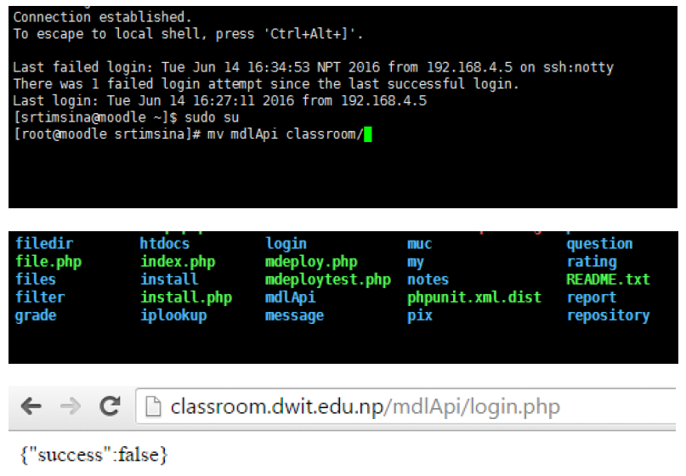

Figure 1-This is first figure

### **2.1.1 This is sub-sub heading**

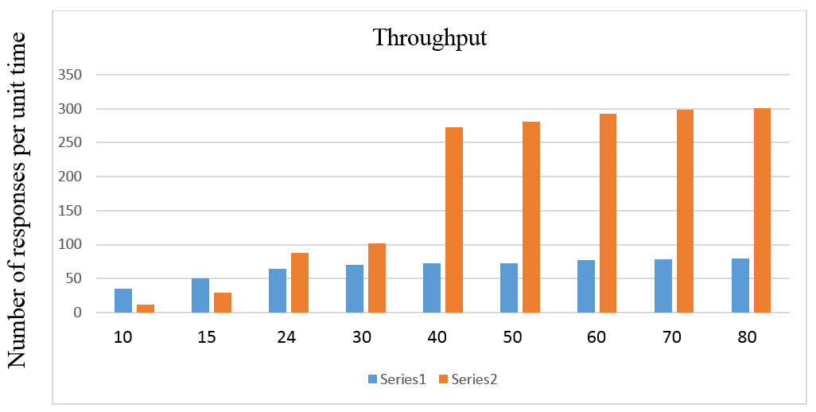

Figure 2-This is figure 2

# **CHAPTER 3: ……………**

Table 1-This is table one

|  |  |  |  |  |
| --- | --- | --- | --- | --- |
|  |  |  |  |  |
|  |  |  |  |  |
|  |  |  |  |  |
|  |  |  |  |  |
|  |  |  |  |  |

# **CHAPTER 4: ………….**

This is next figure …………………..

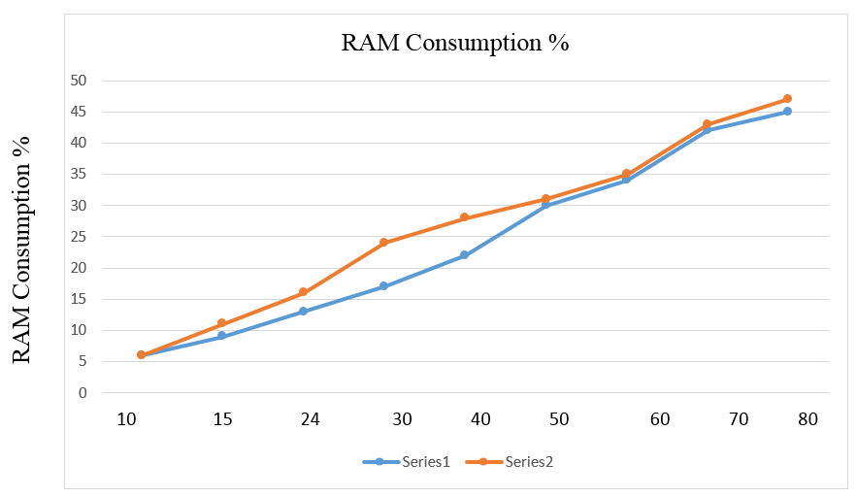

Figure 3-This is third figure

This is next table ………………………..

Table 2- This is second table

|  |  |  |  |
| --- | --- | --- | --- |
|  |  |  |  |
|  |  |  |  |
|  |  |  |  |
|  |  |  |  |

# **CHAPTER 5: ………………..**

# **CHAPTER 6: …………..**

# **APPENDIX I**

# **APPENDIX II**

# **REFERENCES**

# **BIBLIOGRAPHY**

# **PUBLICATION**